Yosemite Home Decor Cascading Water Basin Fountain  http://www.wayfair.com/Yosemite-Home-Decor-Cascading-Water-Basin-Fountain-CW10016-YHD1844.html  $438.⁴⁸  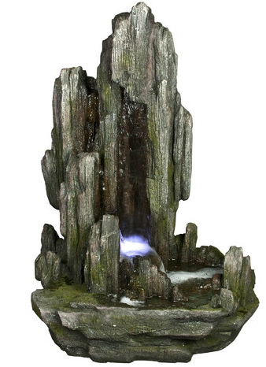 | Alpine Rock Fiberglass Fountain with LED Lights  http://www.wayfair.com/Alpine-Rock-Fiberglass-Fountain-with-LED-Lights-WIN316-ACO1617.html  $389.⁴⁰ 5.0 (1 reviews) BOUGHT  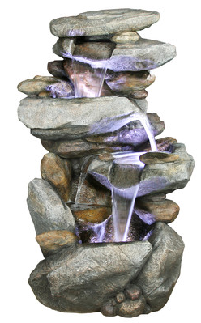
Yosemite Home Decor Two- Tiered Fountain  http://www.wayfair.com/Yosemite-Home-Decor-Two-Tiered-Fountain-CW09040-YHD1831.html  $415.⁹⁹  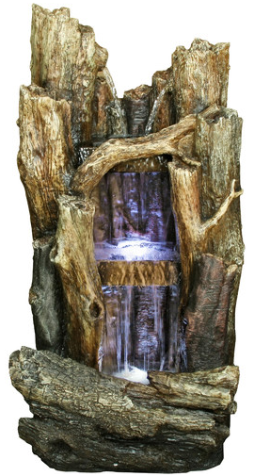 | Alpine Tall Log Fiberglass Fountain  http://www.wayfair.com/Alpine-Tall-Log-Fiberglass-Fountain-WIN258-ACO1337.html#reviews  5.0 (8 reviews)  $499.⁹⁹  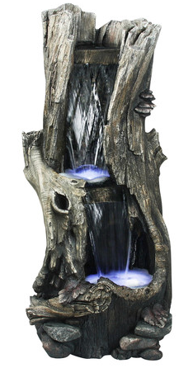
LED Rainforest Vertical Waterfall Outdoor Fountain  Style # X3693  http://www.lampsplus.com/products/led-rainforest-vertical-waterfall-outdoor-fountain__x3693.html  $349.⁰⁰ + FREE SHIPPING*  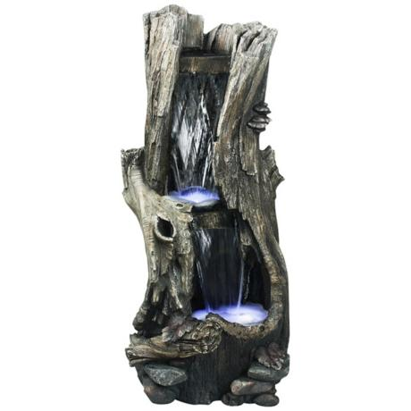 | Yosemite LED Limestone Waterfall Fountain  http://www.lampsplus.com/products/yosemite-led-limestone-waterfall-fountain__3v749.html  $507.⁹¹ + FREE SHIPPING*  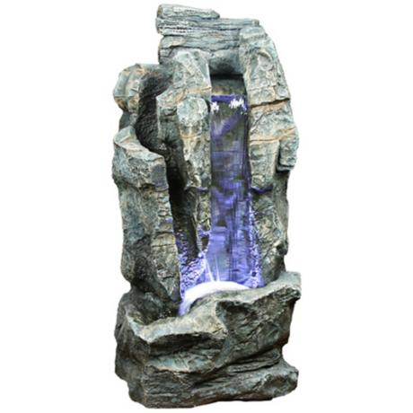
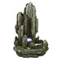http://www.wayfair.com/United-Curtain-Co.-Monte-Carlo-Window-Treatment-Collection-FQC1228-FQC1228.html

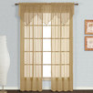 $20 BOUGHT x4
http://www.wayfair.com/United-Curtain-Co.-Monte-Carlo-Ascot-40-Curtain-Valance-MCASC-FQC1162.html

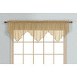 $9.32 BOUGHT x6
http://www.wayfair.com/Beme-International-Facet-Ball-Curtain-Rod-and-Hardware-Set-278246-BMET1026.html
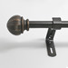 $20.6 (26-48"), $32.33 (48-86") BOUGHT x4 (two short two long)

http://www.wayfair.com/BCL-Drapery-Hardware-Classic-Ball-Curtain-Rod-and-Hardware-Set-58BLG-BDH1045.html
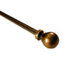$31

http://www.wayfair.com/BCL-Drapery-Hardware-Wire-Twist-Curtain-Rod-and-Hardware-Set-58TWB-BDH1036.html
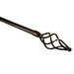$27
http://www.wayfair.com/Gould-NY-Drapery-Hardware-Fashion-Avenue-Braided-Individual-Curtain-Holdback-A5823-GDNY1063.html?redir=gdny1063&rtype=8&dept=&ust=
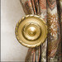
http://www.wayfair.com/Lavish-Home-Twisted-Curtain-Single-Rod-63-19122-LVRG1153.html#reviews
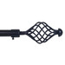$15 (selected) wit for the DIM updated

