Yosemite Home Decor Cascading Water Basin Fountain  http://www.wayfair.com/Yosemite-Home-Decor-Cascading-Water-Basin-Fountain-CW10016-YHD1844.html  $438.⁴⁸  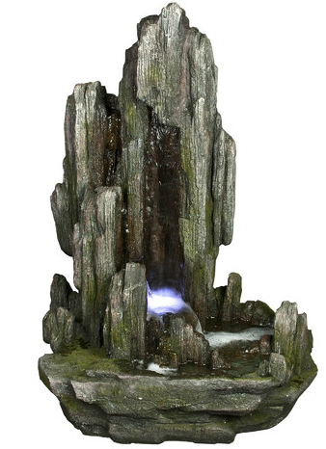 | Alpine Rock Fiberglass Fountain with LED Lights  http://www.wayfair.com/Alpine-Rock-Fiberglass-Fountain-with-LED-Lights-WIN316-ACO1617.html  $389.⁴⁰ 5.0 (1 reviews)  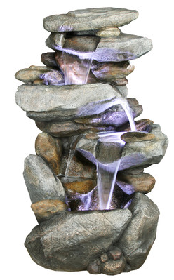
Yosemite Home Decor Two- Tiered Fountain  http://www.wayfair.com/Yosemite-Home-Decor-Two-Tiered-Fountain-CW09040-YHD1831.html  $415.⁹⁹  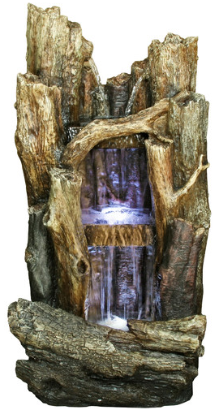 | Alpine Tall Log Fiberglass Fountain  http://www.wayfair.com/Alpine-Tall-Log-Fiberglass-Fountain-WIN258-ACO1337.html#reviews  5.0 (8 reviews)  $499.⁹⁹  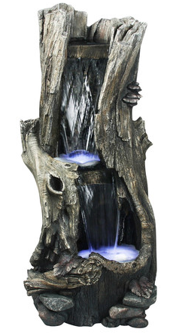
LED Rainforest Vertical Waterfall Outdoor Fountain  Style # X3693  http://www.lampsplus.com/products/led-rainforest-vertical-waterfall-outdoor-fountain__x3693.html  $349.⁰⁰ + FREE SHIPPING*  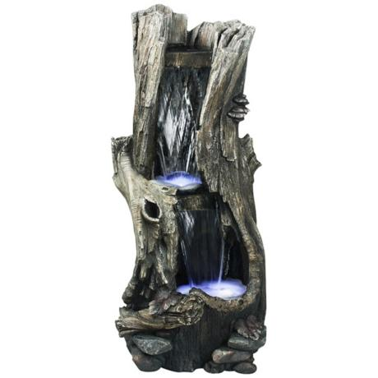 | Yosemite LED Limestone Waterfall Fountain  http://www.lampsplus.com/products/yosemite-led-limestone-waterfall-fountain__3v749.html  $507.⁹¹ + FREE SHIPPING*  